Overview of the App

QuizUp is a popular trivia-based mobile application designed to engage users in competitive knowledge games. Launched in 2013, QuizUp allows players to test their knowledge across a wide array of topics, ranging from general knowledge to highly specialized fields such as pop culture, history, and science. The app features both single-player and multiplayer modes, where users can challenge friends or compete with random opponents from around the world (Hindy, 2014).

Strengths

1. Diverse Topic Range: QuizUp distinguishes itself with an extensive selection of quiz topics. Users can choose from hundreds of categories, which not only makes the app appealing to a broad audience but also ensures that players with niche interests can find content that resonates with them (Hindy, 2014).

2. Engaging Multiplayer Mode: The app's competitive multiplayer feature is a major strength. It allows users to face off against friends or strangers in real-time, adding a layer of excitement and social interaction. The ability to see how one’s knowledge stacks up against others in real time is a compelling draw for users. (Anand, 2014)

3. User-Friendly Interface: QuizUp is known for its vibrant and intuitive user interface. The app is designed with visually appealing graphics and smooth animations that enhance the user experience. The easy navigation ensures that users, even those who are new to trivia games, can quickly find and start playing their favorite quizzes. (Hindy, 2014)

Weaknesses

1. Ad Disruptions: One of the notable drawbacks of QuizUp is its reliance on frequent advertisements. These ads can be intrusive and disrupt the flow of gameplay, potentially diminishing the overall user experience. While ads are a common monetization strategy for free apps, balancing them to minimize disruption is crucial (Hindy, 2014).

2. Internet Dependency: The app’s multiplayer features and many of its quizzes require a constant internet connection. This can be limiting for users with unreliable internet access or those who wish to play offline. (Anand, 2014).

3. A weakness of QuizUp is that some questions are unnecessarily difficult, focusing on obscure details that most users wouldn't know. This can lead to frustration, as the challenge feels more confusing than fun, making players feel discouraged rather than entertained (Hindy, 2014),

Implementation Assumptions

QuizUp’s technical setup likely uses Firebase along with custom APIs. Firebase is ideal for real-time features, such as instantly updating quizzes and scores during multiplayer games. A REST API is probably used to handle quiz data, like questions and answers from different categories.

The app also likely uses custom views and animations to create its unique quiz layout and interactive experience. Android Studio helps build these features, ensuring smooth integration of visuals and interactions. Firebase's fast data handling and real-time updates enhance performance and keep users engaged with the app.

Screenshots

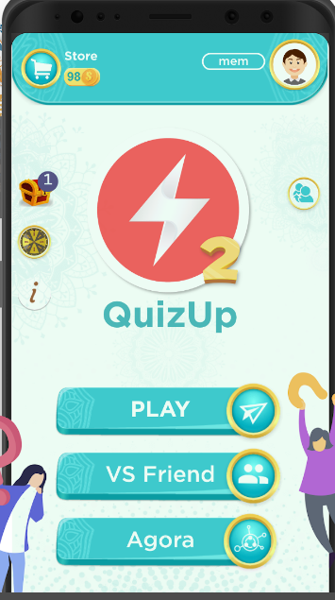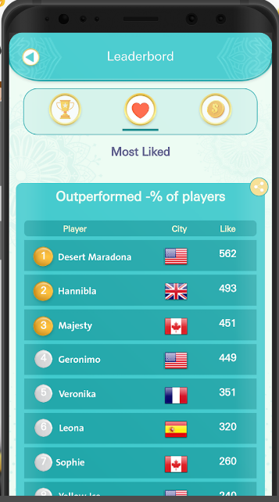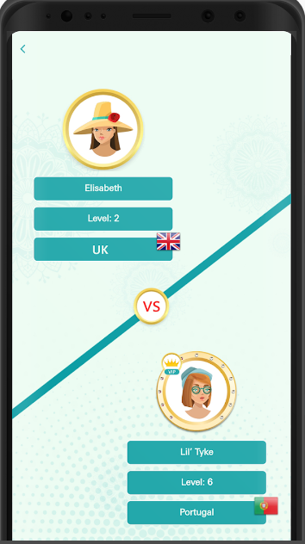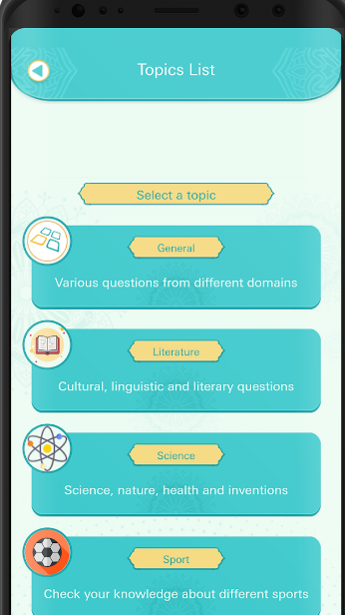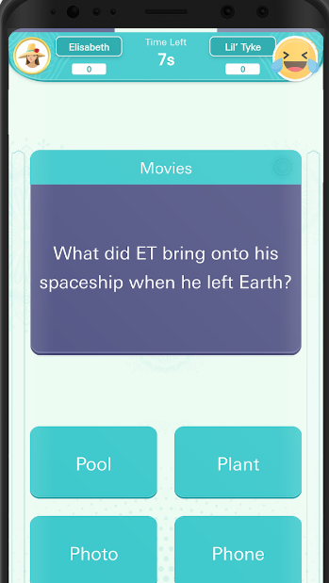

Overview of the App

Trivia Crack is a widely recognized mobile quiz application that captivates users with its engaging trivia game mechanics. Released in 2013, the app features a unique gameplay system where players answer questions across six distinct categories: Science, Entertainment, Art, Geography, Sports, and History. A defining element of Trivia Crack is its spinner, which randomly selects a category for each round, adding an element of chance and excitement to the game.

Strengths

1. Engaging Game Mechanics: Trivia Crack’s combination of trivia knowledge and luck offers a dynamic and enjoyable experience. The spinner introduces a random element that can affect the outcome of each game, making it more unpredictable and exciting. This blend of strategy and chance keeps players engaged and coming back for more (Cipriani, 2015).

2. Strong Community and User-Submitted Questions: Trivia Crack boasts a robust community of players who contribute to the app’s content. The inclusion of user-submitted questions allows for a diverse and continually expanding question bank. This community-driven aspect helps ensure a broad range of trivia questions and can foster a sense of involvement and ownership among users (Callaham, 2018).

Weaknesses

1. In-App Purchases: While Trivia Crack offers free access to its core features, it also includes in-app purchases that can impact gameplay. These purchases often provide advantages such as additional spins or power-ups, which can create an uneven playing field. Players who choose not to spend money may find themselves at a disadvantage, which could detract from the overall fairness of the game (Cipriani, 2015).

2. Design Flaw Exploitation: Trivia Crack had a flaw that let some users cheat by intercepting the app's data. This data included the next question and its correct answer. By seeing this information before the question appeared, these users could always choose the right answer. This flaw gave them an unfair advantage and disrupted the fairness of the game. It shows why it's important to secure how app data is sent and received (Chippa, 2014).

3. Intrusive Ads: Many users express concerns about the presence of advertisements in Trivia Crack. Some ads are not only frequent but may also be inappropriate for younger audiences, making the game less suitable for children. These ads can interrupt gameplay and detract from the overall experience. While ads are a standard way for free apps to generate revenue, ensuring that they are age-appropriate and balancing their frequency could greatly enhance user satisfaction (Cipriani, 2015).

Implementation Assumptions

Trivia Crack’s architecture likely relies on a server-side system to manage its extensive question bank and handle user interactions. This backend infrastructure supports the app’s dynamic content delivery and ensures that questions are updated regularly. Google Play Services is probably utilized for in-app purchases and leaderboard integration, enabling players to make transactions and compare their scores with others.

The spinner mechanic, a signature feature of Trivia Crack, is likely implemented using custom animations and physics-based calculations. This feature adds a layer of visual appeal and randomness to the game. The app’s developers would use animation libraries and possibly physics engines to create a visually engaging and smooth spinning experience that integrates seamlessly with the game’s overall design.

Screenshots

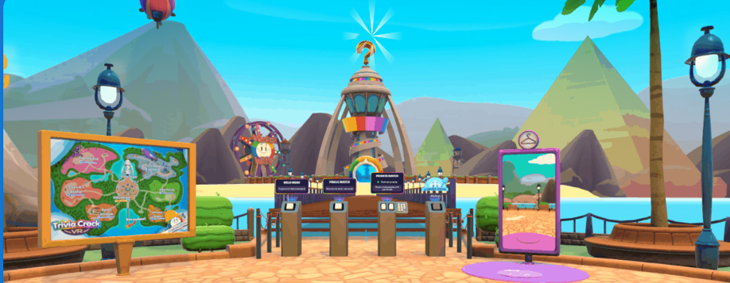

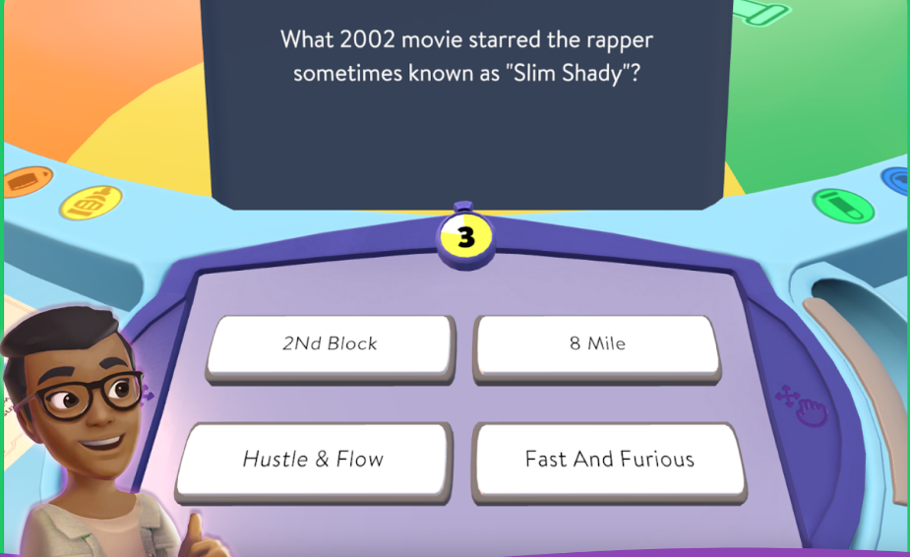

Comparison of All Three Apps

User Engagement: QuizUp and Trivia Crack focus on competitive play, while Kahoot! excels in group interaction, particularly in educational settings.

Content Variety: QuizUp offers the most extensive range of topics, whereas Kahoot! stands out for its user-generated content.

Monetization: All three apps rely on ads and in-app purchases, with varying degrees of impact on user experience.

Best Features to Include in the Final App

Multiplayer Mode: Inspired by QuizUp, a competitive mode that allows users to challenge friends or random opponents.

Category Variety: Drawing from Trivia Crack, a wide range of quiz categories should be available to appeal to different interests.

User-Generated Content: Like Kahoot!, the app should allow users to create and share their own quizzes, fostering a community-driven experience.

**Reference List**

Anand, D. 2014. Quizup , 11 February 2014. [Online]. Available at: <https://blogs.ischool.berkeley.edu/i290-dme-s14/2014/02/11/quizup/> [Accessed 18 August 2024].

Chippa. 2014. The cracks in Trivia Crack, 29 December 2014. [Online]. Available at:

<https://medium.com/@iamchippa/the-cracks-in-trivia-crack-3fac78b50f38> [Accessed 18 August 2024].

Cipriani, J. 2015. Trivia Crack review: A trivia game as addictive as it is fun, 24 January 2015. [Online]. Available at:

<https://www.cnet.com/reviews/trivia-crack-review/> [Accessed 18 August 2024].

Callaham, J. 2018. Trivia Crack hit with growing pains thanks to a flood of user-submitted questions. 29 August 2018 [Online]. Available at:

<https://www.windowscentral.com/trivia-crack-hit-growing-pains-thanks-flood-user-submitted-questions> [Accessed 18 August 2024].

Hindy, J. Quizup Review, 10 March 2014. [Online]. Available at:

<https://www.androidauthority.com/quizup-review-355780/> [Accessed 18 August 2024].